Title:
Adaptive e-Learning Model as a Solution for Current e-Learning Challenges

First Author, Corresponding Author:
Haitham A. El-Ghareeb
Associate Lecturer, Information Systems Department
Faculty of Computers and Information Sciences, Mansoura University
Egypt

Home Address:
40 Adel el Refaey Street, Mahalla Kobra, 31911
Gharbia, Egypt
Mobile: 0020122330847
Email: helghareeb@acm.org

Prefer Communication On Home Address

Second Author:
Alaa M. Riad
Head of Information Systems Department, Faculty of Computers and Information Sciences, Mansoura University, Egypt
Mobile: 0020127972713
Email: amriad2000@mans.eud.eg

Third Author:
Hamdy K. El-Minir
Head of Communications Department, Misr Higher Engineering Institute and Technology, Mansoura
Mobile:0020106973875
Email: hamdy_elminir2@yahoo.com
Adaptive e-Learning Model as a Solution for Current e-Learning Challenges

Abstract
E-Learning solutions face challenges that are leading a group of researchers to doubt the efficiency of such an experience. Challenges include lack of adaptation in the e-Learning process. Though adaptive and intelligent features in information systems and e-Learning are many, they have not been utilized in the most efficient manner. This lack of utilization is due to many reasons; mainly architectural. Service Oriented Architecture (SOA) - as a design pattern presenting systems as collection of reusable services that can be exposed and consumed on the Internet with standard interfaces - has many advantages that can be achieved on technical, managerial and implementation aspects of the system. It can be useful in integrating long decades and efforts of adaptive and intelligent features of e-Learning in e-Learning systems today. This paper addresses some of the challenges facing the e-Learning process today. Proposed Adaptive Learning Model is presented as a suggested solution to the highlighted problems. Today, e-Learning information systems architects can make use of SOA in integrating major e-Learning components together, side by side with adaptive and intelligent features to provide students with required personalized learning environment.
Keywords: e-Learning, Adaptive e-Learning, Service Oriented Architecture (SOA), Information Systems’ Integration, SCORM Learning Objects.

Introduction
E-Learning can be thought of as the learning process created by interaction with digitally delivered content, services, and support. E-Learning involves intensive usage of Information and Communication Technology (ICT) to serve, facilitate, and revolutionize learning process (Ma, 2006; Horton, 2003; Moore, 2003).
Learning paradigms/methodologies include traditional learning - face-to-face -, distance learning - complete asynchronous time and place learning delivery; mainly online - and blended learning - learning that combines instruction lead learning with online learning activities leading to reduced classroom contact hours.
Blended Learning has the potential to increase student learning while lowering attendance rates compared to equivalent fully online courses (Dziuban, Hartman, Moskal, 2004). Blended Learning is the learning paradigm that attempts to optimize both traditional learning and distance learning advantages, potentials and benefits, while eliminating both learning paradigms shortages and challenges.
When compared to traditional learning paradigm, Blended Learning is found to be consistent with the values of traditional learning paradigm adopted in almost all higher education learning institutions for decades. Blended Learning has the proven potential to enhance both the effectiveness and efficiency of meaningful learning experiences (Garrison & Kanuka 2004).
Learning Management System (LMS) is the software that automates the administration of education. LMS registers students, tracks courses in a catalogue, records data from learners and provides reports to management. LMS is typically designed to handle courses by multiple publishers and providers. It usually doesn’t include its own authoring capabilities; instead, it focuses on managing courses created by a variety of other learning resources. Britain and Liber (1999) present a prototypical LMS. LMS was meant to support different learning models.
This paper goes as follows: The following section presents the survey results of the selected group of faculty students, highlighting the Problem Definition. Next, the paper presents the adaptive learning model as the proposed solution. Then, the paper presents the Proposed Solution IT Architecture, followed by how to utilize SOA in integrating different proposed IT Architecture components. Later on, the Sharable Content Object Reference Model (SCORM) utilization in the proposed model is presented. Finally, the paper is concluded.

Problem Definition
Current Blended Learning Model Paradigm faces different pedagogical and technological challenges (Sahin, 2010). As indicated by a great majority of recent studies, the key issues in developing effective learning models are the adoption of adequate pedagogical paradigms that make educated use of the special technological features of learning technologies (Eshet-Alkalai & Aydin, 2009). On the other side, although technologies are advanced today, the technologies used in teaching and education are less advanced (Riad, El-Minir, El-Ghareeb, 2009).
A number of recent articles have commented that science education is no better today than it was fifty years ago. The National Assessment of Education Progress (NAEP) shows that today, in most areas students are achieving at about the same levels as students who were tested in 1971 (Bork, Bagley, Zhang, 2008). This issue is the result of:
- The attempt to use whatever technology currently or will be available in the near future without pedagogically considering student or the learning process.
- Allowing technology to stand against the learning process, because no matter what advancement we have achieved, technology still limits our dreams, which is applicable in the case of e-Learning these days.
- The poor evaluation for many of the available innovations. Most of the required evaluations are either inadequate or do not exist at all.
Bork, Bagley, Zhang (2008) argue that some of the reasons why technology has not led to improvements in learning globally are:
- Grabbing Onto Each New Technology: The belief that each new technology will enhance learning needs more arguments about efficiency than just belief.
- Failure to Continue Successful Development: Funders often prefer to look for something new rather than follow up on successful approaches, because they want to make a mark by being in the forefront. Funders want to make a statement, and following up on someone else’s work doesn’t provide them with the credit or “name” they desire.
Pedagogically, most training methods and technologies produce - at best - “trained novices”. That is, they introduce facts and concepts to students, present them with relatively simple questions to test this new knowledge, and provide them with a few opportunities to practice using this knowledge in exercise or scenarios. However, to be an expert requires extensive practice solving realistically complex problems in wide range situations, combined with coaching and feedback from managers, more experienced peers or other types of experts (Ong & Ramachandram, 2003).
Today, most evaluations of presented technologies in the learning model focus on technology aspects of the solution, and ignore the pedagogical aspect, almost at all. The result of using technology, particularly computers, in learning has not been impressive so far. A variety of studies and opinions have questioned the use of technology to improve learning. Although it has been many years since computers were used in the learning environment, there is a little improvement in learning, with or without technology.
Although the use of technology in learning shows no significant difference, i.e., computer learning is no better than traditional instruction, learners were provided with the convenience of any time, any place learning. Students’ understanding and retention improves when they learn by experience. Technologies such as collaboration, interactivity, modelling, simulations, virtual reality interfaces and gaming will help students experience the skill being taught. Yet, they have not helped students that far (Bork, Bagley, Zhang, 2008). Besides, the students’ lack of awareness regarding different e-Learning technologies stand up against the presentation of effective e-Learning model.
Later in the year 2008, authors conducted a pilot study for fourth year Information Systems department students at the faculty of Computers and Information Sciences in Mansoura University, Egypt.
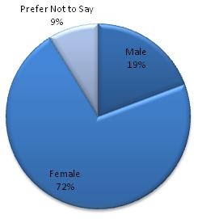
Figure 1 Gender Distribution
Figure 1 presents the gender distribution of participating students. Although the 57 students who conducted the questionnaire answered that they heard about e-Learning, and they all believe it is effective, the authors found out that almost 25% of the participating students do not use Internet as their main source of information as shown in the Error: Reference source not found. This is considered weird when compared to the 100% e-Learning efficiency commit. What are the odds of using e-Learning not based on the Internet? And what are the odds of finding an updated source of information that competes with the Internet?
Error: Reference source not found provides us with the following information:
- 83% of students classified themselves as good Internet users, while 72% of them do not even know what “tutorials” are. Web based tutorials is one of the main sources for teaching students.
- Although 83% of participants believe they can learn via e-Learning, and almost the same percentage agree to participate in an e-Learning, only 68% of students appeared to be accepting the idea of using mobile in learning purposes.
- Though Mobile Learning (M-Learning) is an important e-Learning research field, the study shows that only 28% of students access Internet via their mobile phones, and only 46% of students are willing to participate in a free of charge mobile learning experience when asked to.
- If learning via mobile is a challenging experience to the researchers due to mobile limited resources, mobile assessment has been recognized as one of the mobile learning activities that can be achieved effectively (Riad & El-Ghareeb, 2008).
- 61% of the students said that they will not participate in a mobile assessment experience when they are asked to.
- 58% of the students believe that M-Learning will not become popular.
- Finally, all students participated in the pilot study agreed that the authors’ faculty utilizes different forms of e-Learning.
Though the faculty of the authors does not provide an official site for e-Learning, any online courses, assessment site or any other form of e-Learning other than the authors’ attempts, students still believe that e-Learning is efficient - even if they have not experienced it at all. We believe this means that most e-Learning researchers around speak more than they work, and claim more than they justify. Students believe that e-Learning is effective without trying it, and are not excited about M-Learning regardless to the researches that the e-Learning researchers provide.
Table 1 Pilot Study for Fourth Year Students
 | Strongly Agree | Agree | Disagree | Strongly Disagree
Internet is main source of Information | 38% | 38% | 24%
Good Internet User | 25% | 58% | 17%
Familiar with Tutorials | 14% | 14% | 53% | 19%
Students Can Learn via e-Learning | 23% | 60% | 17%
Participate in e-Learning | 18% | 68% | 14%
Use Mobile Learning | 12% | 56% | 32%
Access Internet via Mobile Phones | 7% | 16% | 49% | 28%
Participate in M-Learning Experience | 9% | 37% | 54%
Participate in M-Assessment Experience | 7% | 32% | 61%
M-Learning will become Popular | 5% | 37% | 58%

Proposed Solution
With many different backgrounds, learning styles, and interest, Adaptive Learning for students is almost a must. Educational psychologists largely agree that students differ greatly in the ways they learn, and very few teachers or professors can adapt learning to each student in the typical large classes, and the costs associated with delivering different instruction for varied learning styles is prohibitive (Bork, Bagley, Zhang, 2008).
In Alfred Bork’s experiments (2008), the most successful learning strategy was tutoring. Adaptive e-Learning supported with intelligent techniques is one of the ways to support personalized e-Learning. Thus, authors believe that it will be the way to solve many of the limitations and e-Learning challenges today.
Authors reviewed the different adaptive and intelligent e-Learning systems proposed over a long e-Learning research era. These reviews highlighted the maturity of adaptive and intelligent features and the e-Learning researchers attempt to introduce services based e-Learning systems in order to overcome many of the e-Learning challenges – such as reusability, scalability, integration and interoperability (Riad, El-Minir, El-Ghareeb, 2009).
Authors concluded with the need to present a new learning model that uses the best of what was presented before, faces the challenges and avoids the mistakes. Though authors believe there is not a single unified learning model that can be the only right model, hopefully this work will be a step towards a better learning model supported by the appropriate technologies. We present an Adaptive e-Learning Model that utilizes SOA in providing integration and interoperability between different learning systems to provide students with adaptive features that personalizes the learning process.

Proposed Model Components
Figures 2 and 3 present the proposed learning process using BPMN 2.0. BPMN 2.0 is the modelling language provided by Object Management Group (OMG). It is specifically designed to illustrate complex business processes. Proposed learning process requires the integration of different systems to achieve the required goal. There are four sub systems; presented by vertical pools in Error: Reference source not found:
- Adaptive Learning Management System (Adaptive LMS): The sub information system responsible for providing the adaptation features to each student via determining the learning road, topics and time required for each student based on their performance, learning profile and recorded learning history.Quality Assurance and Accreditation Project (QAAP): An Egyptian National Initiative and Project that is maintained by the Egyptian Ministry of Higher Education. It aims at enhancing the quality of the Egyptian learning in higher education institutions by maintaining high standards in different aspects of the learning process. More information can be found at http://www.qaap.net/heep.htm. Two aspects are important to our system: Course Specification Module, and Instructor Module. Course Specification Module focuses on defining and determining courses contents, learning objectives and other course resources. Instructor Module contains the instructor time table that will be used to define suitable times for meetings between students and instructors when needed.
- Exam Management System: Due to security issues and while seeking to achieve the best method to prevent cheating, a blended model of online exams and desktop application exam will be available. Students will run the desktop application on times pre-determined for exams. The desktop application will retrieve questions from online repositories. Those repositories are maintained by Learning Content Management System (LCMS).
- Learning Content Management System (LCMS): It is critical and vital to the success of the proposed model implementation. LCMS holds questions items based on Question and Test Interoperability (QTI) Specification v. 1.2 Standard, and Learning Objects based on SCORM 2004 Standard.

Proposed Model Learning Scenarios
To make the proposed model clearer, we will illustrate in words what takes place with students. Instructor has already prepared the learning materials based on SCORM 2004 Standard and classified those learning materials to satisfy specific learning topics. Student (A) uses the system for the first time. Student (B) used the system before and did well through learning, and now has a due exam. Student (C) failed twice before in the exam, and is attending the exam for the third time.
Student (A) attempts to log in but as it is the first time, s/he finds her/himself forced to register. During registration, the student completes the learning profile. S/he can skip this process and completes it later. The second time the student logs in, the Student Learning Sub system tends to retrieve the student learning preferences from student learning profile subsystem. If it is not complete; the system forces the student to complete it before starting to learn. Otherwise, the Student Learning System extracts the student information and registered courses, then checks if this student has an exam. Student (A) does not have an exam, so again, the Student Learning System checks if s/he has a meeting with an instructor. Student (A) does not have a meeting, so the Student Learning System calls QAAP Course Specification Module via QAAP Data Adapter Service, and acquires the course specifications and list of topics and keywords. The Student Learning System displays to the student the list of topics; available and unavailable as a result of the requirements pre-requisites, so the student can define the roadmap.

Insert Figure 2 here: Proposed Learning Model

Insert Figure 3 here: Proposed Learning Model (cont.)

The student selects the topics that s/he wants to learn. The Student Learning Profile is then updated with the selected / deselected topics. The Student Learning System displays the suitable learning material and a list of recommended learning materials and what others have seen learning material list. The Student Learning System qualifies the student to make sure s/he understands the learning objectives of the topic. If the student is not qualified, then s/he goes back to the study plan.
The Student can quit learning at any time to continue later from her/his library section. Then the Student Learning System checks if the topics that the student has learned form an exam, then the student now becomes eligible for an exam. The Student can - upon her/his choice - go through Learn via Questions (LVQ) experiment. LVQ is a sub system that simulates the exam environment by presenting questions with feedback, so students can measure their readiness for an exam. The main objective of LVQ is helping students define their readiness level, not testing them. If a student wants to skip LVQ, s/he receives an exam date, and the learning process moves to Student (B).
Student (B) logs in to the system and s/he has a due exam, so the Student Learning System attempts to initialize the desktop application. The exam application retrieves questions from LCMS questions repository based on the exam ID submitted by the Student Learning System, The exam application ranks the exam, and updates the student profile with this rank. The next time the student logs in, s/he finds her/himself continuing learning new topics.
Student (C) faces troubles with some topics. S/he attended the exam twice but did not pass. So, the third time s/he logs in, attends the exam and does not pass, s/he automatically sees the instructor’s calendar to pick the suitable time for meeting. The meeting details with the student’s detailed profile are mailed to the instructor. The next time the student logs in, s/he finds the system paused and the calendar is displayed. Only the instructor can solve the situation after meeting the student by reactivating the student account after the proper action has been taken and recorded in the study profile. The instructor can illustrate the topic more than once to the student, examines her/him orally, written or whatever method the instructor finds appropriate.
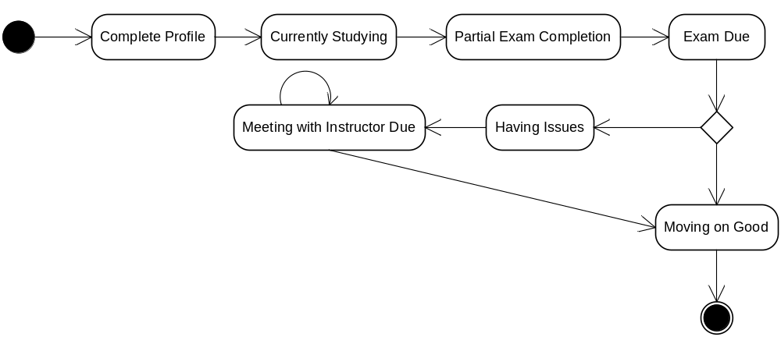
Figure 2 Student State Transition Diagram

Adaptive Features in Proposed Model
There are four main approaches that can be used to give a historical overview of Adaptive e-Learning. They are Macro Adaptive, Aptitude-Treatment Interaction (ATI), Micro-Adaptive and Constructivistic-Collaborative approaches. (Modritscher, Manuel, Garcia-Barrios, Gütl, 2004). Here, we present a mapping between the four approaches and our proposed model adaptive features.

1. Macro Adaptive Approach
This approach addresses adaptation of instructions on a macro-level by allowing different alternatives in selecting a few main components such as learning objectives, levels of details, delivery system, etc. In this approach, instructional alternatives are selected mostly on basis of the student’s learning goals, general abilities and achievement levels in the curriculum structure. The proposed model addresses this capability by testing the student profile and learning preferences before establishing learning material.

2. Aptitude-Treatment Interaction (ATI) Approach
This approach treats adaptation of instructional strategies to specific students’ characteristics. This strategy proposes different types of instructions or even different media types for different students.
One aspect of the ATI approach is the user’s control over the learning process according to the abilities of the students, by giving them full or partial control over the instruction style. Level of control can be one of three levels:
- Complete independence
- Partial control within a given task scenario
- Fixed tasks with control of pace.
The proposed model addresses this approach by allowing the students to choose among the topics to learn (within the constraints of the pre-requisites). This gives them the partial control experience. Also, the proposed model provides the capability to arrange meetings between the instructors and students that have issues with certain learning topics.
Students are given the chance to self-study the subjects and attend the exams 3 times. If the student fails to pass the exam 3 times, a meeting must be arranged between the instructor and the student to submit a repost by the instructor to the student profile, so the student can continue the learning process again in the adaptive way. This sort of blended learning gives strength to the proposed model.

3. Micro-Adaptive Approach
This approach addresses adaptation of instructions on a micro-level by diagnosing the student’s specific learning needs during instruction, and then, providing instructional recommendations for these needs. Researchers have attempted to establish micro-adaptive instructional models using on-task rather than pre-task measures.
Monitoring the user’s behaviour and performance - such as response errors, response latencies, emotional states, etc - can be used to optimize instructional treatments and sequences on a very refined scale (Gutl, Manuel Barrios, Modritscher, 2003). The proposed model addresses this approach by providing the capability to calculate the required time to study for each learning topic.

4. Constructivistic-Collaborative Approach
An important element of this approach is the usage of collaborative technologies which are considered often as essential component of e-learning. Adaptive system enables learning by focusing on how knowledge is learned and should consider the context, learning activities, cognitive structures of the content, and the time extension.
Online forum, wiki and blog services will be available to students to enhance collaborate and help each other. Facilities to enable online study groups - like chatting applications - can be made available. Arguments around the effectiveness of Web 2.0 features in e-Learning are taking place all around.
Error: Reference source not found presents a summary of the mapping between proposed adaptive features in the proposed learning model and the four adaptive learning approaches. In addition, the proposed model combines both Adaptable and Adaptive capabilities. Adaptability made available by giving students the capability to define and edit their personal preferences, which will affect directly their learning experience.
Table 2 Summary of Proposed Model's Adaptive Features and Adaptive Learning Approaches
Adaptive Feature of the Proposed Model | Adaptive Learning Approach
Adaptation of Instructions on a Macro Level | Macro Adaptive Approach
Allowing Students to select among the topics to learn taking in consideration pre-requisites | Partial Control, Aptitude Treatment Interaction (ATI) Approach
Suspend Account and Arrange Meetings with Instructors based on Learning Situations | Aptitude Treatment Interaction (ATI) Approach
Online Forum, Wiki, Blog, Chatting, Grouping Services | Constructivistic – Collaborative Approach

Proposed Solution IT Architecture
Proposed solution IT is complex, and includes the utilization of different technologies to achieve the required goal. There are already installed and running systems that cannot be changed at once. Though those systems are not old enough, but we will refer to them as legacy systems; they are out of scope to us, however, the proposed solution needs these systems along with their data.
SOA utilization has many advantages over other software architecture paradigms in solving integration challenges (Riad, El-Bakry, El-Ghareeb, 2009). They are QAAP, Joomla and Moodle as illustrated in Figure 3.
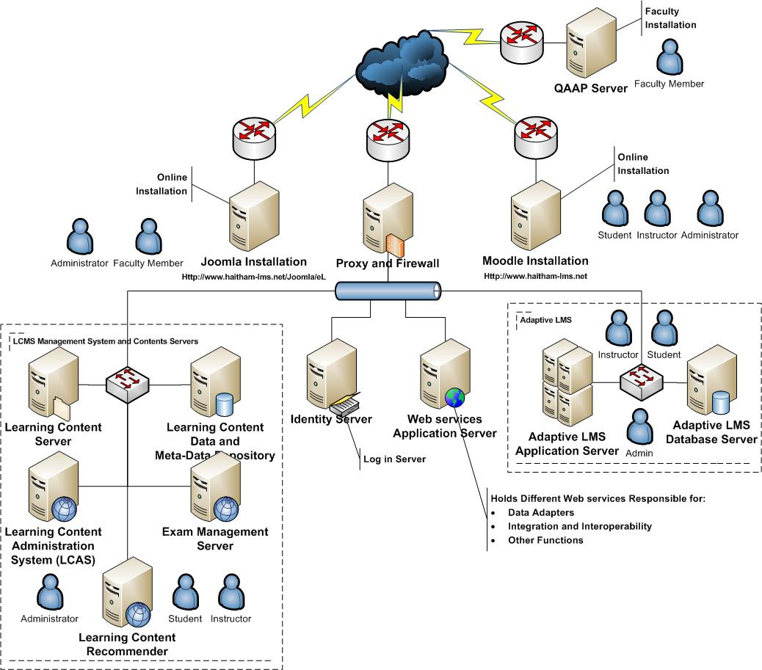
Figure 3: Proposed Solution IT Architecture
QAAP server is managed by the faculty members internally, and it includes applications that are related to the course specifications and instructors. Moodle is an open source LMS that is widely accepted and used over learning institutions to provide online learning facilities and management capabilities. Joomla is an open source Content Management System (CMS) used to manage and publish online contents. So, to implement the proposed learning model, IT modifications shall be presented as follows:
- Proxy and Firewall Server shall be added at the gate between online and external systems, and the proposed Model Server Components.
- Identity Server shall be added to enable single sign-on authentication and authorization capabilities for the whole solution.
- Web services Application Server: shall be added to hold Web services responsible mainly for:
- Data Adapter: Accessing data stored at QAAP, Moodle and Joomla.
- Integration and Interoperability: Between different servers based on different required functionalities.
- Learning Content Management System (LCMS) and Content Servers: Logically, the following servers are required to manage the presented functionalities:
- Learning Content Server: To hold the learning materials physical files. Different implementation can include FTP Server.
- Learning Content Data and Meta-Data Repository: To maintain SCORM v. 2.0 Data and Meta-Data about learning materials. The data will be used to determine the appropriate learning materials for the students.
- Learning Content Administration System (LCAS): Holds the application that enables administrators to manage learning content files, learning content data and learning content meta-data. Different LCAS functionalities are presented in Figure 4 that display LCAS use case diagram.
- Exam Management Server: Manages exam process and accesses LCMS questions based on exam IDs.
- Learning Content Recommender: Works on the learning contents data, meta-data, students learning profiles, students learning history and instructors’ recommendations to recommend learning materials to students.
- Adaptive LMS: Responsible for providing adaptive features presented in the proposed model and providing the main interface for students to access the Web application.
- Adaptive LMS Application Server: Holds the portal that can be accessed by students.
- Adaptive LMS Database Server: Holds the student profiles, learning preferences and learning history.
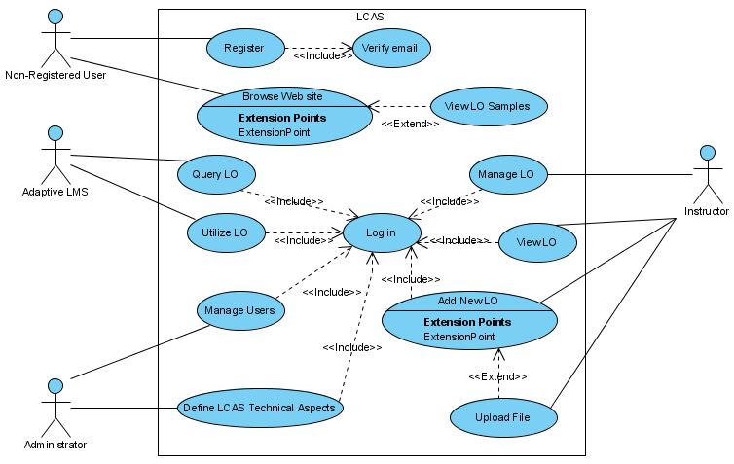
Figure 4: LCAS Use Case Diagram

Integration of Proposed Model Components Via SOA
A combination of both Business Process Management (BPM) and Service Oriented Architecture (SOA) is proven to achieve numerous advantageous features for systems. The proposed model presented an adaptive learning process that adaptively changes based on students performance.
SOA is the utilized architecture in integrating the different components required to support the proposed adaptive learning process. SOA is the architectural design that presents systems as collection of services grouped together to satisfy the system requirements. Our proposed model composing services can be categorized in the layers depicted in Figure 5.
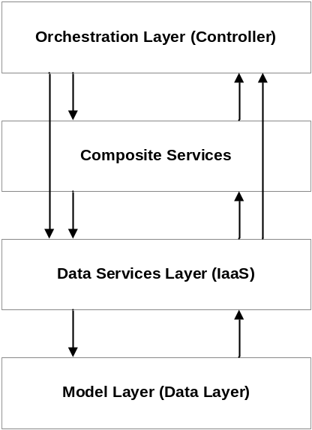
Figure 5: Proposed Model Layered Architecture

Error: Reference source not found presents a summary of proposed layer services, mapped with proposed model IT infrastructure diagram to highlight the implementation of the services, and what services were actually utilized. Table 2 layers are:
- Orchestration Layer: holds services responsible for maintaining learning process logic and activities. It includes services that utilize both composite services’ layer services, and data services’ layer services.
- Composite Services: are services that holds other services and don’t complete functioning unless all composing services execute successfully; however it is not controlling them
- Data Services Layer (Information as a Service “IaaS”): is the layer that holds services responsible for transforming Meta-data into meaningful information to other utilizing information systems, instructors, and students. Figure 8 presents an E-R Model for Sharable Content Object Reference Model (SCORM) v. 2.0 utilized standard to describe learning content data and meta-data. Learning object has mainly five aspects: educational, technical, meta-data, copyrights, and lifecycle. General entity in the middle of the diagram is connected to the abovementioned five main entities that represent each of the previous aspects. Data adapters for accessing external system components are presented in this layer. QAAP data adapter, Joomla data adapter, and Moodle data adapter are presented for accessing QAAP, Joomla, and Moodle servers respectively.
- Model Layer (Database): it is rather the database layer that holds data tables. Figure 18 presents the SCORM v. 2.0 database tables for Learning Objects data and meta-data.

Table 3: Summary of Proposed Model Services, Categorized by Architecture Layers, and Mapped to
IT Infrastructure
Design Layer | Service Name | Parent System | NW Diagram Server | Utilized Services
Orchestration Layer (Controller) | O1: Search for Learning Object | Adaptive LMS | Adaptive LMS AS | C1,C2
Orchestration Layer (Controller) | O2: Learn New Topics | Adaptive LMS | Adaptive LMS AS | D2, D3, D4, D5
Orchestration Layer (Controller) | O3: LVQ “Learn Via Questions” | LVQ
Orchestration Layer (Controller) | O4: Meetings with Instructor | Adaptive LMS |  | D5,D10
Composite Services | C1: Adaptive Search | LCMS | Learning Content Recommender | D1,D5
Composite Services | C2: Intelligent Search | LCMS | Learning Content Recommender | D1
Data Services Layer (IaaS) | D1: Learning Objects Manager | LCMS | LCAS | DB1
Data Services Layer (IaaS) | D2: Lessons Manager | Adaptive LMS | Adaptive LMS AS | DB2
Data Services Layer (IaaS) | D3: Topics Manager | Adaptive LMS | Adaptive LMS AS | DB2
Data Services Layer (IaaS) | D4: Course Manager | Adaptive LMS | Adaptive LMS AS | DB2
Data Services Layer (IaaS) | D5: Student Profile Manager | Adaptive LMS | Adaptive LMS DB Server | DB3
Data Services Layer (IaaS) | D6: Questions Manager | LCMS | Exams Management Server | DB4
Data Services Layer (IaaS) | D7: Exams Manager | LCMS | Exams Management Server | DB4
Data Services Layer (IaaS) | D8: Questionnaires Manager | Adaptive LMS | Adaptive LMS AS | DB3
Data Services Layer (IaaS) | D9: Course Module Adapter | QAAP | Web Services Application Server | --
Data Services Layer (IaaS) | D10: Instructor Data Adapter | QAAP | Web Services Application Server | --
Data Services Layer (IaaS) | D11: Moodle Data Adapter | Moodle | Web Services Application Server | --
Data Services Layer (IaaS) | D12: Joomla Data Adapter | Joomla | Web Services Application Server | --
Model Layer (Databases) | DB1: Learning Objects (Data and Meta-Data) | LCMS | Learning Content Data and Meta-Data Repository | --
Model Layer (Databases) | DB2: Lessons, Topics and Courses | Adaptive LMS | Adaptive LMS DB Server | --
Model Layer (Databases) | DB3: Student Profiles and Questionnaires | Adaptive LMS | Adaptive LMS DB Server | --
Model Layer (Databases) | DB4: Questions and Exams | LCMS | Exams Management Server | --

SCORM and Proposed Model
In the below figures (Error: Reference source not found and Error: Reference source not found), we present an overview of SCROM v.2.0 based E-R Diagram and database tables that are implemented in the proposed model. SCORM is the utilized standard to store meta-data about LOs. LO is the basic building block of a learning resource; it is the electronic representation of media, such as text, images, sounds, assessment objects or any other piece of data that can be rendered by a Web client and presented to a learner. LO’s meta-data can be grouped into three main categories from the authors’ point of view: General, Educational and Technical.
- General: This category groups the general information that describes the resource as a whole. It stores data about keywords, description, structure and aggregation levels.
- Technical: The Technical category describes all of the technical characteristics and requirements of the SCORM Content Model Component. Technical category focuses on format, size, installation remarks of the LO as well as the requirements for running the LO.
- Educational: The Educational category describes the key educational or pedagogic characteristics of the LO. This category allows for the description of the educational characteristics and is typically used by teachers, managers, authors and learners. It focuses on data like interactivity type, interactivity level, typical age range of the LO and context.

Insert Figure 8 here: SCORM v. 2.0 E-R Model

Insert Figure 9 here: SCORM v. 2.0 Database Table

Conclusion
There is a clear need for adaptive and intelligent features in the current e-Learning systems to provide students with personalized learning environments they need. One of the e-Learning challenges that became clear after surveying 57 students in the year 2008 was the absence of current e-Learning systems to adaptively and intelligently touch students’ capabilities.
This paper presented an adaptive learning model that blends instructor lead education with e-Learning capabilities.
Presenting adaptive and intelligent features as services with standard interfaces will allow different e-Learning systems to adopt them, so they will be reusable, and the newly introduced information systems will not have to reinvent the wheel again. Besides, wrapping adaptive and intelligent features with standard interfaces will present a separation of interests that help adaptive and intelligent features’ researchers and developers to focus more on their target, and transfer the responsibility of utilizing these features in different information systems to information systems specialists.
Today’s e-Learning information systems’ architects can make use of SOA in integrating major e-Learning components together, side by side with adaptive and intelligent features. Different M-Learning activities can be also presented and integrated. Future work includes utilizing different algorithms and intelligent techniques in providing proposed system functionalities. There is a growing attention to the importance of Semantic Web in the near future to introduce Web 3.0. Semantic Web challenges of the proposed system are Semantic Web Calendar, and Semantic Web Search Engines.

References
Alfred Bork, Carole A. Bagley, Xiwen Zhang, “Technology and Learning: A proposal for Adaptive Learning Tutorial”, Michael Allen's 2008 e-Learning Annual, J-B Pfeiffer Annual Looseleaf Vol1, 2008.
A. M. Riad, and H. A. El-Ghareeb, “A Service Oriented Architecture to Integrate Mobile Assessment in Learning Management Systems”, Turkish Online Journal of Distance Education - TOJDE April 2008 ISSN 1302-6488 Volume: 9 Number: 2 Article 12.
A. M. Riad, Hamdy K. El-Minir, Haitham A. El-Ghareeb, “Review of e-Learning Systems Convergence from Traditional Systems to Services based Adaptive and Intelligent Systems”, Journal of Convergence Information Technology, Vol. 4, No. 2, June 2009
A. M. Riad, Hazem M. El-Bakry, Haitham A. El-Ghareeb, “Mapping Different Software Architecture Paradigms to Different Integration Techniques: Highlighting Driving and Restraining Forces for Each Paradigm”, Journal of Convergence Information Technology, Vol. 4, No. 2, June 2009
Charles D. Dziuban, Joel L. Hartman, Patsy D. Moskal, “Blended Learning”, Vol. 2004, Issue 7, Educase Connect, 2004
Christian Gutl, Victor Manuel Barrios, Felix Modritscher, “Adaptation in E-Learning Environments through the Service-Based Framework and its Application for AdeLE”, IDC: US Corporate and Government eLearning Forecase, 2003
D. Randy Garrison, and Heather Kanuka, “Blended learning: Uncovering its transformative potential in higher education”, The Internet and Higher Education, Volume 7, Issue 2, 2nd Quarter 2004, pp. 95-105.
Felix Modritscher , Victor Manuel, Garcia-Barrios , Christian Gütl, "The Past, the Present, and the Future of adaptive E-Learning", Proceedings of the International Conference on Interactive Computer Aided Learning (ICL2004), 2004
James Ong, Sowmya Ramachandram, “Intelligent Tutoring Systems: Using AI to improve Training Performance and ROI”, Stottler Henke Associates Inc., 2003
Mehmet Sahin, "Blended learning model in mechanical manufacturing training", African Journal of Business Management Vol. 4(12), pp. 2520-2526, 2010
Michael Graham Moore, “Handbook of Distance Education”, Lawrence Erlbaum Associates, 2003
Sandy Britain, Oleg Liber, “A Framework for Pedagogical Evaluation of Virtual Learning Environments”, JTAP - JISC Technology Application Programme, University of Wales - Bangor, 1999
Willam Horton, Catherine Horton, “E-Learning Tools and Technologies”, Wiley Publishing Inc., 2003
Yoram Eshet-Alkalai and Cengiz Hakan Aydin, "Regional Focus Issue Editorial:
A Bridge over Troubled Waters: Learning Technologies in the Middle East ". The International Review of Research in Open and Distance Learning, Vol. 10, No 2, 2009.
Zongmin Ma, "Web-Based Intelligent E-Learning: Technologies and Applications", Information Science Publishing, 2006

